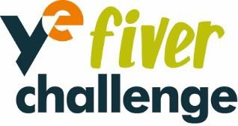

Dear Parent(s)/Carer

This year we are participating in the Fiver Challenge, a free national competition for young people aged from 5 – 11 years. The challenge is run by Young Enterprise, the UK’s leading enterprise and financial education charity, which helps bring learning to life and helps to encourage future aspirations in young people.

More details on the Fiver Challenge can be found at www.fiverchallenge.org.uk, where you can also register as a parent/carer to access the resources.

During the challenge pupils are pledged £5 and have four weeks to research, create, plan and run their own mini business, either in a team or working independently. There will be an opportunity to enter competitions along the way, including the best logo design, best sales pitch and the National Competition, where they could win great prizes and be featured in the Fiver Showcase. The £5 pledge will be provided by Young Enterprise or the school and pupils will decide how to spend or donate their profit. It’s a great programme supporting children to gain core enterprise skills such as communication, confidence and creativity and its great fun too!

The Fiver Challenge for Scotland and Northern Ireland will take place from Monday 15th May - Friday 9th June 2023. Any support and encouragement you can give your child during this activity would really be appreciated.

We are all very excited about getting involved with this Challenge!

Yours faithfully,

